Say Something Week

At Sands Montessori, we are committed to promoting a healthy school community and developing the whole child. We work hard to promote a peaceful environment and teach students to be peacemakers by following our school wide expectations: care for self, care for environment, and be kind to others.

November 13-17 the Sands Montessori Community will participate in “Say Something Week “, a program that was adapted from the Sandy Hook Promise. We will be discussing how to help students care for others by telling a trusted adult when someone is being hurtful to self or others. Activities will be planned to meet the developmental needs of each level. The entire student, staff, and school wide community will be encouraged to wear a tee shirt designed for Say Something Week on Wednesday, November 15.
Last week, all students were invited to submit a design illustrating what being a peacemaker means to them. The students voted and have selected the winning design submitted by 4th Grader, Adrian Mejia Camarote. Please join us in showing your support for Say Something Week by using the pre-order form below.

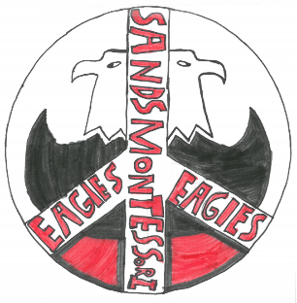

To ensure we order the correct sizes please fill out your student’s name; room number and info below. Please use a line for each child
The cost for the tee is $5.00 each. Donations are encouraged; any additional funds will be used to order a tee for a student in need. Please include cash only. Please send form with payment back to school with your student by Monday, October 9.

S 6-8
M 10
L 12
XL 14-16

Size options XS-XL (Youth) and XS-XL (Adult)
Name | Grade/Room # | Size (include adult or youth)

